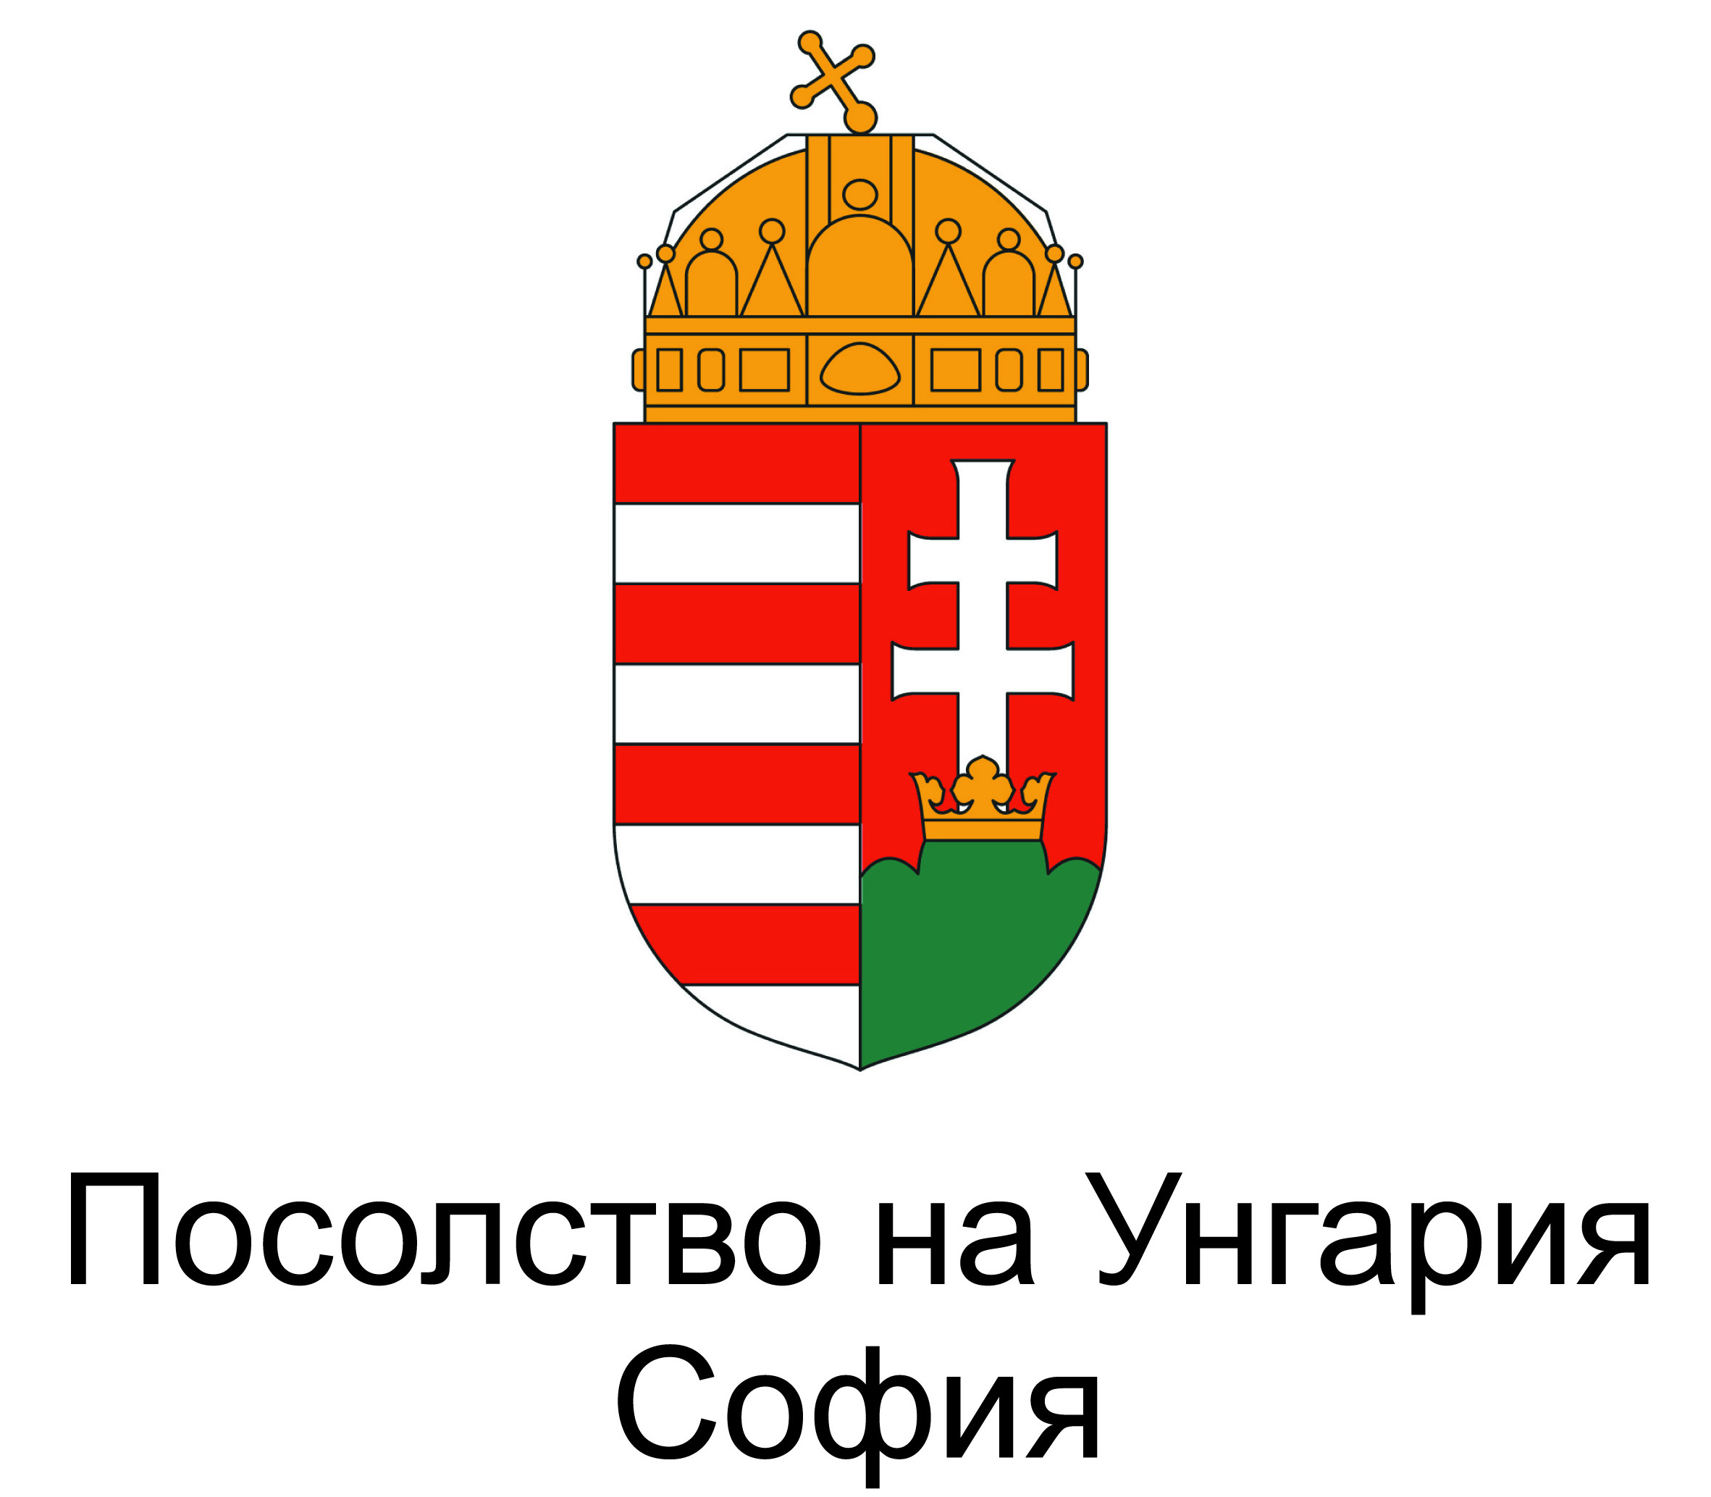
Until 1989, the dedication of one of the most substantial and fundamental works of Lazar Nikolov, representing Bulgarian New Music - the opera “Prometheus Bound” - is not officially announced. Even when I conducted a number of interviews with him, in the beginning of the 90^{s}, he related to me the fact that since its very inception and creation, the opera was tacitly dedicated to the Hungarian Revolution of 1956. Lazar Nikolov’s connection between his opera and the Hungarian Revolution against communism is not well known, already for three decades. I still think though, that this connection must remain in the nation’s cultural memory.
Lazar Nikolov is one of the creators of the Bulgarian Neue Musik and twelve-tone avant-guard of the second half of the 20th century. He and Konstantin Iliev achieve their project of twelve-tone music within the totalitarian regime’s conditions. In the 50^{s} of the 20th century they establish the modernistic project for contemporary music, and subsequently fall prey to the totalitarian censure. Especially prominent is the year 1956. Then, Lazar NIkolov’s works are banned, by order of the presidium of the Union of Bulgarian Composers. The same year, the composer begins to plan the opera “Prometheus Bound.” It is one of the composer’s brightest modernistic opuses. Its idea, as previously stated, and according to the composer’s later testimony, is related to the 1956 Hungarian Revolution’s inspiration. This remains unannounced, a deeply intimate act in the composer’s mind, connected to the protest towards totalitarian art doctrine.
1956 is a “fateful” year also for the Bulgarian literature and music. In the latter, the poet’s Yordan Ruskov’s fate stands out. For Nikolov, this year is related to an important life decision. This year indeed is a year of maximum pressure, and clash of different ideas.
What is the events’ chronology? In 1956, a “Decade of Symphonic Arts” gets organized; in literature, it is being celebrated as the year of the “won” socialist order; in music, it is marked by active persecution of formalism in music, to be more exact, in some of Konstantin Iliev and Lazar Nikolov’s œvre. Their music becomes an object of a censure decision of the Union of Bulgarian

Composers - according to it, some of their works cannot be performed in public without UBC’s permission.
In the autobiographic memoire of Lazar Nikolov, the year 1956 has a particular focus and events intertwining: 1. He is ultimately being proclaimed an “unacceptable formalist” - leading to understandable consequences, also 2. He travels to Warsaw, and visits the first “Warsaw Autumn”, and finally 3. He writes his autobiographical memory about his stay in Hungary during the uprising at the end of October - a significant event for him.
Year 1956, according to Lazar Nikolov, emphasizes his tendency to focus his art towards the new music and the avant-guard. This focus’ has its crucial significance, connected to global changes occurring in the communist bloc, the Hungarian Revolution and Gomułka’s regime in Poland. Nikolov’s dedication of his opera to the Hungarian Revolution is linked to the composer’s autobiographical memoire - at that time Nikolov is in Hungary. This is how he remembers it: “During the Warsaw autumn, the Poles replaced their General Secretary with Gomułka. The Soviet Union was very unhappy about this choice, but could not interfere, the Poles went towards a different cultural direction in their politics. When we climbed aboard the train to return to Bulgaria through Warsaw, it was the night train at the end of October. Then, on station Galanta, one Hungarian person told me that since yesterday there is a revolution in Hungary… it was cold, without bread. We arrived in Serbia, Belgrade, with a great delay.” Six years later, in 1962, Nikolov begins work over “Prometheus.” In its very inception and primeval impulse, exists the unofficial dedication to the Hungarian Revolution, intrinsically connected to the composer’s memoire of 1956. The fact that this dedication is unofficial is significant. It is deeply personal part of the plot, with an autobiographical element, and it is present in the opera’s esthetic fabric and language.
Layers of “hidden content” and messages in cypher, inaccessibility, are related to the twelve-tone music’s poetics. In Lazar Nikolov’s case and his opera, these cases have a particular significance. The opera’s dedication could not be made public within the conditions of Bulgaria’s ideologically controlled situation, prior to 1989. Even its performance (in 1971), already at some distance from 1956, is “half-official.”
This opera’s essence is in the absolute uprising, executed in silentio. Prometheus’ figure, for Nikolov, is the figure of differentiation from the official regime. When dividing horizons of power/discontent and revolt, it is this hero’s implacability, his stamina, that are important. This work’s dedication is intertwined with author’s stance of interpreting the esthetic rebellion as fate. Violence’s sphere is brutal; the main hero’s silence is extreme and otherworldly. Such an esthetic solution has no exact analogue in Western New music.
Having said that, we may ask ourselves what is the extraordinary element related to this work’s dedication? Primarily - Bulgarian New Music and its representative works, like this opera - are naturally dissociated with “officiality.” Such works strive to exist in a parallel space with West European modernism, despite their obvious inability to openly communicate.
Thus, this unofficially proclaimed dedication of “Prometheus Bound” to the Hungarian Revolution of 1956 is an important fact; it has a significant accent within this fundamental author’s position of protest, an author greatly prominent in Bulgarian New Music. Doubtless, it outlines an important aspect of connection between Hungarian and Bulgarian culture - under the auspices of the rebellious 1956.

